**Spiritual Warfare (Part Five – Shoes of Peace)**

**6 10** Finally, be strong in the Lord and in the strength of his might.   
 **11** Put on the whole armor of God, that you may be able to stand   
 against the schemes of the devil.   
 **12** For we do not wrestle against flesh and blood, but   
 against the rulers,   
 against the authorities,   
 against the cosmic powers over this present darkness,   
 against the spiritual forces of evil in the heavenly places.   
 **13** Therefore take up the whole armor of God,   
 that you may be able to withstand in the evil day, and   
[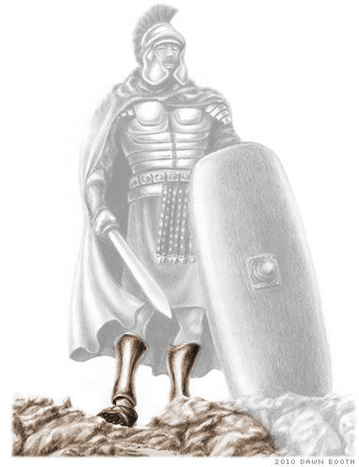](http://www.freebiblestudyguides.org/bible-teachings/whole-armor-of-god.jpg) having done all, to stand firm.   
 **14** Stand therefore having fastened on the belt of truth and   
 having put on the breastplate of righteousness.

|  |  |
| --- | --- |
| ESV | And, as shoes for your feet, |
|  |  |
| Literal | and having shod the feet |
| Transliteration | kai hypodēsamenoi tous poudas |
| Greek | καὶ ὑποδησάμενοι τοὺς πόδας |
|  |  |
|  |  |
| ESV | having put on the readiness |
|  |  |
| Literal | with (the) readiness |
| Transliteration | en hetoimasia |
| Greek | ἐν ἑτοιμασίᾳ |
|  |  |
|  |  |
| ESV | given by the gospel of peace |
|  |  |
| Literal | of the gospel of peace |
| Transliteration | tou euangeliou tēs eirēnēs |
| Greek | τοῦ εὐαγγελίου τῆς εἰρήνης |

