**Spiritual Warfare (Part Six – Shield of Faith)**

**6 10** Finally, be strong in the Lord and in the strength of his might.   
 **11** Put on the whole armor of God, that you may be able to stand   
 against the schemes of the devil.   
 **12** For we do not wrestle against flesh and blood, but   
 against the rulers,   
 against the authorities,   
[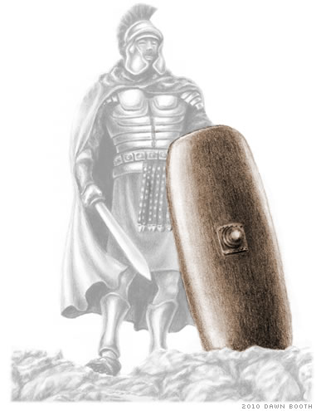](http://www.freebiblestudyguides.org/bible-teachings/whole-armor-of-god.jpg) against the cosmic powers over this present darkness,   
 against the spiritual forces of evil in the heavenly places.   
 **13** Therefore take up the whole armor of God,   
 that you may be able to withstand in the evil day, and   
 having done all, to stand firm.   
 **14** Stand therefore having fastened on the belt of truth and   
 having put on the breastplate of righteousness. **15** And, as   
 shoes for your feet, having put on the readiness given by   
 the gospel of peace.

|  |  |
| --- | --- |
| ESV | In all circumstances take up the |
|  |  |
| Literal | Besides all having taken up the |
| Transliteration | En pasin analabontes ton |
| Greek | ἐν πᾶσιν ἀναλαβόντες τὸν |
|  |  |
|  |  |
| ESV | shield of faith, with which you can |
|  |  |
| Literal | shield of faith with which you will be able |
| Transliteration | [thyreon](https://biblehub.com/greek/thyreon_2375.htm) [tēs](https://biblehub.com/greek/te_s_3588.htm) [pisteōs](https://biblehub.com/greek/pisteo_s_4102.htm) [en](https://biblehub.com/greek/en_1722.htm) [hō](https://biblehub.com/greek/ho__3739.htm) [dynēsesthe](https://biblehub.com/greek/dyne_sesthe_1410.htm) |
| Greek | θυρεὸν τῆς πίστεως ἐν ᾧ δυνήσεσθε |
|  |  |
|  |  |
| ESV | extinguish all the flaming darts of the evil one; |
|  |  |
| Literal | all the arrows of the evil one flaming to quench |
| Transliteration | [panta](https://biblehub.com/greek/panta_3956.htm) [ta](https://biblehub.com/greek/ta_3588.htm) [belē](https://biblehub.com/greek/bele__956.htm) [tou](https://biblehub.com/greek/tou_3588.htm) [ponērou](https://biblehub.com/greek/pone_rou_4190.htm) ta [pepyrōmena](https://biblehub.com/greek/pepyro_mena_4448.htm) [sbesai](https://biblehub.com/greek/sbesai_4570.htm) |
| Greek | Πάντα τὰ βέλη τοῦ πονηροῦ τὰ πεπυρωμένα σβέσαι |