[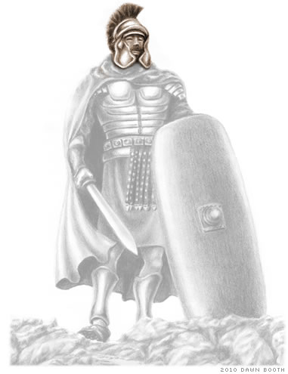](http://www.freebiblestudyguides.org/bible-teachings/whole-armor-of-god.jpg)**Spiritual Warfare (Part Seven – Helmet of Salvation)**

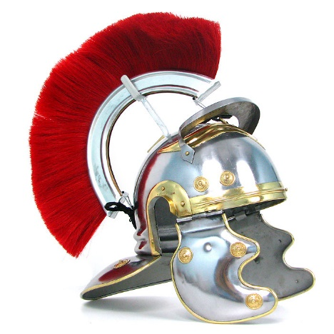**6 10** Finally, be strong in the Lord and in the strength of his might.   
 **11** Put on the whole armor of God, that you may be able to stand   
 against the schemes of the devil.   
 **12** For we do not wrestle against flesh and blood, but   
 against the rulers,   
 against the authorities,   
 against the cosmic powers over this present darkness,   
 against the spiritual forces of evil in the heavenly places.   
 **13** Therefore take up the whole armor of God,   
 that you may be able to withstand in the evil day, and   
 having done all, to stand firm.   
 **14** Stand therefore having fastened on the belt of truth and   
 having put on the breastplate of righteousness. **15** And, as   
 shoes for your feet, having put on the readiness given by   
 the gospel of peace. **16** In all circumstances take up the shield   
 of faith, with which you can extinguish all the flaming darts   
 of the evil one.

|  |  |
| --- | --- |
| ESV | and take the helmet of salvation |
|  |  |
| Literal | and the helmet of salvation take |
| Transliteration | kai [tēn](https://biblehub.com/greek/te_n_3588.htm) [perikephalaian](https://biblehub.com/greek/perikephalaian_4030.htm) [tou](https://biblehub.com/greek/tou_3588.htm) [sōtēriou](https://biblehub.com/greek/so_te_riou_4992.htm) [dexasthe](https://biblehub.com/greek/dexasthe_1209.htm) |
| Greek | καὶ τὴν περικεφαλαίαν τοῦ σωτηρίου δέξασθε |
|  |  |
|  |  |
|  |  |
|  |  |
|  |  |
|  |  |
|  |  |
|  |  |
|  |  |
|  |  |
|  |  |
|  |  |
|  |  |
|  |  |